# Class work day 5

3) Write a program to rin n prime numbers then find the nth Prime number 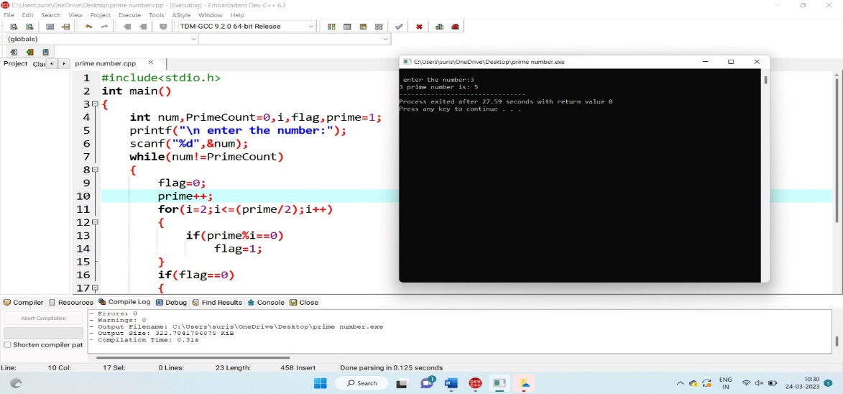

4) Write a c program to modify the constant variable in c?

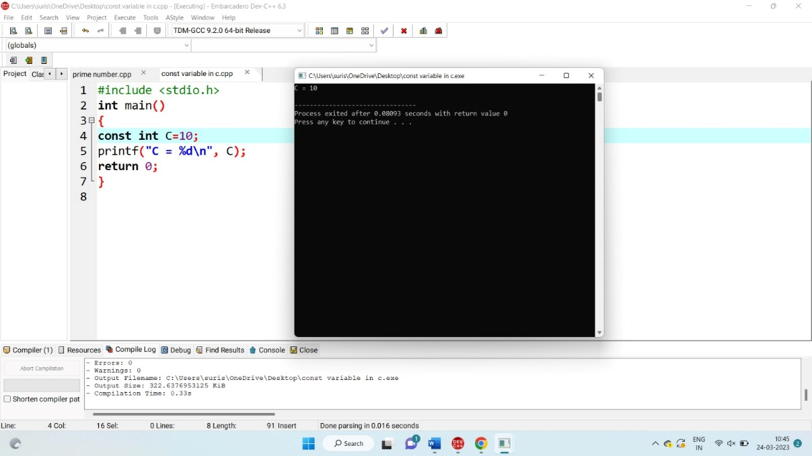

7)Write a program to guessing a number by the user against computer generated one using do while loop

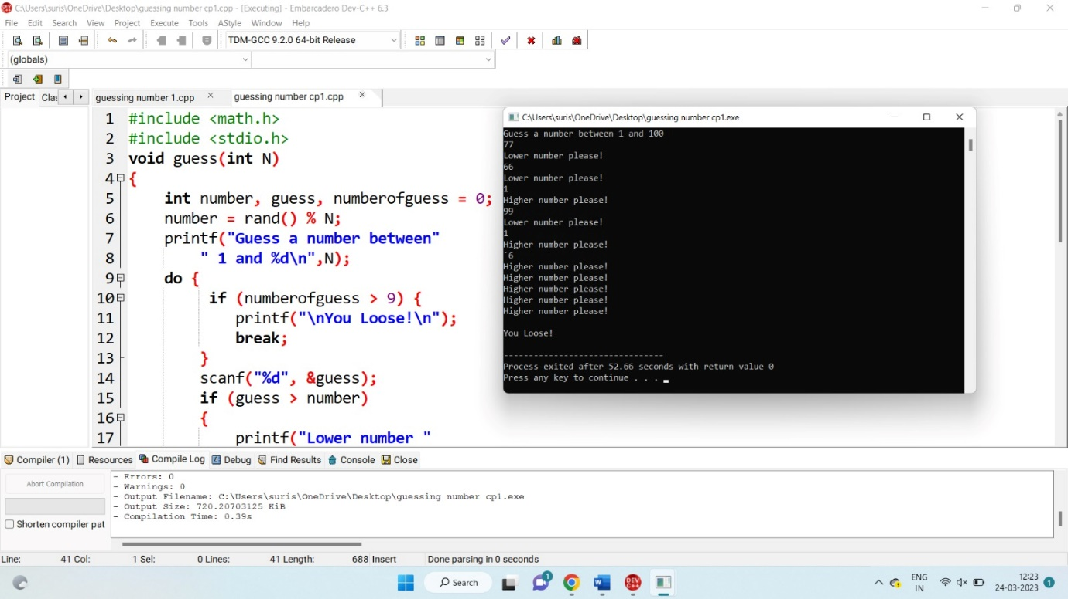

To write a C code to implement a function to compute power of a value

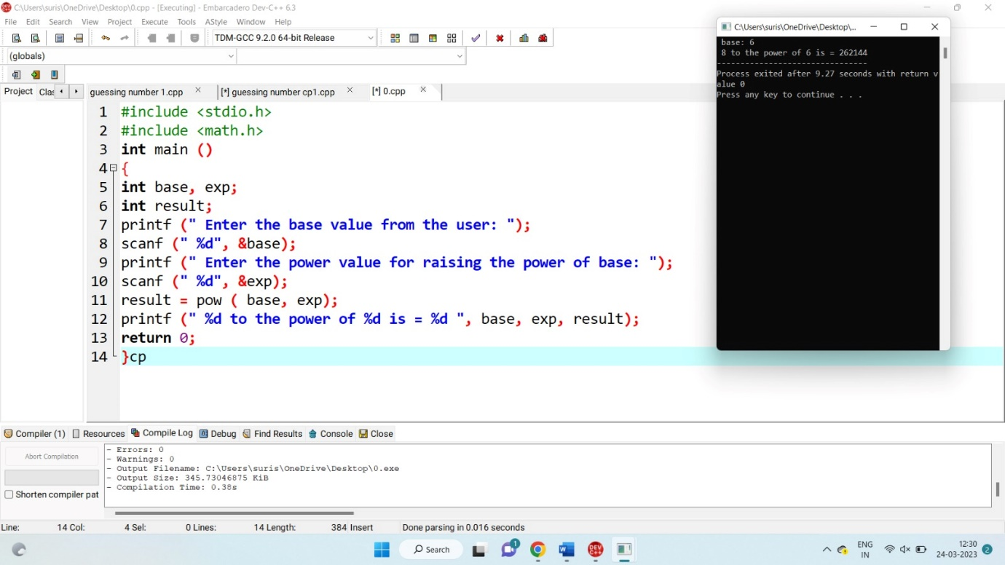

To write a C code to implement Nested Structure concept



Program to add two numbers using Function with no arguments and no return value



Program to add two numbers using Function with arguments and with return value

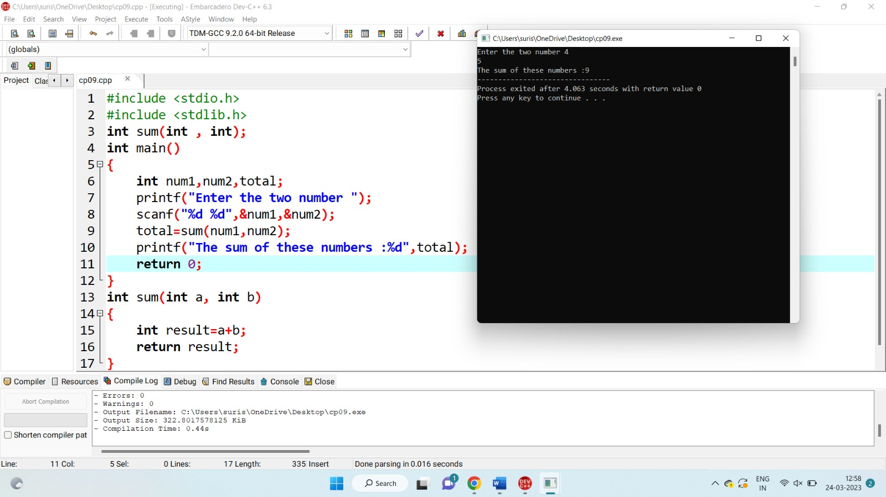Program to swap two numbers using call by value

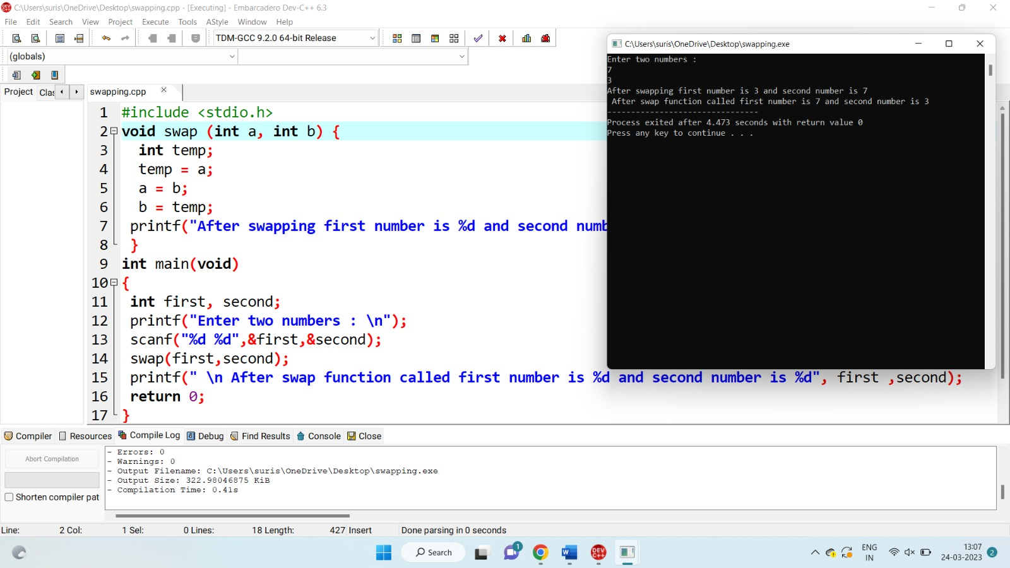

Program to swap two numbers using call by reference

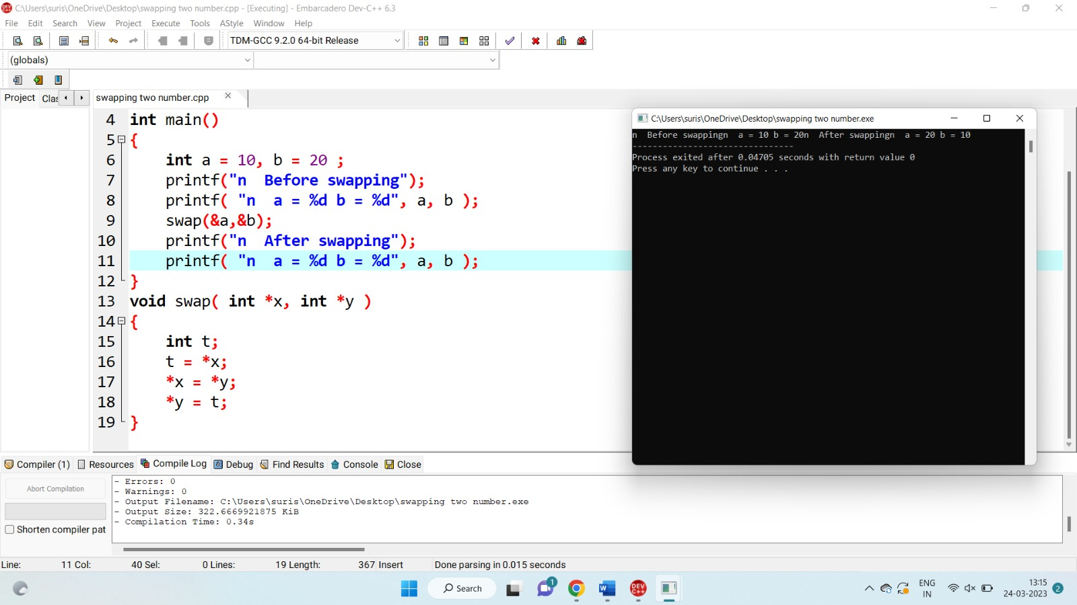

Write a program for Binary Search using recursive functions

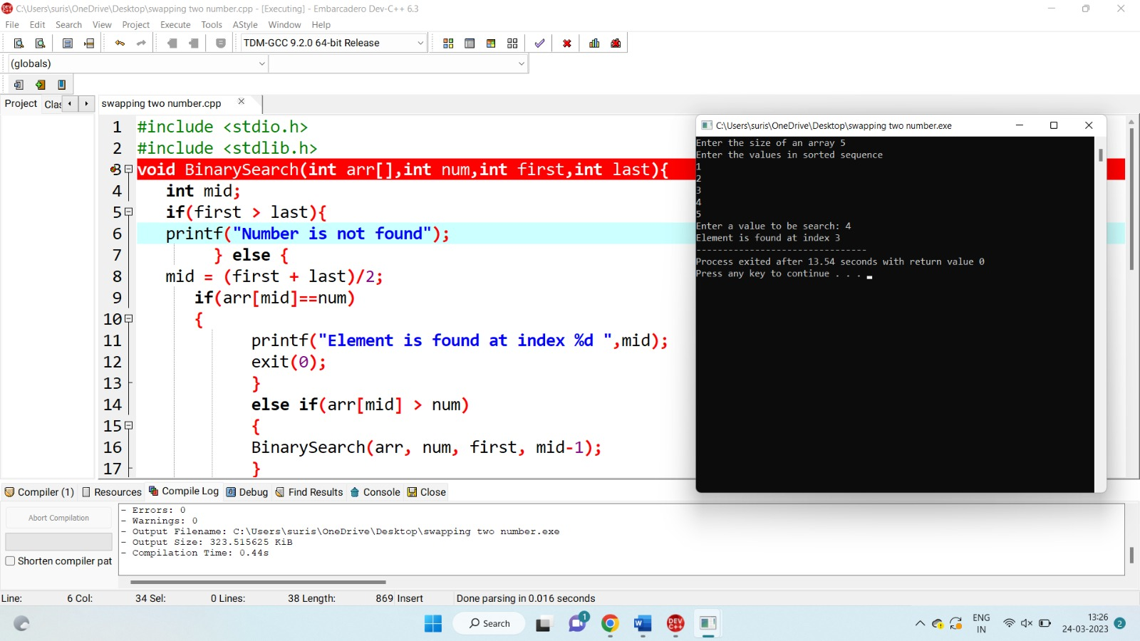

Program to find Employee no, name, salary, doj using nested structure

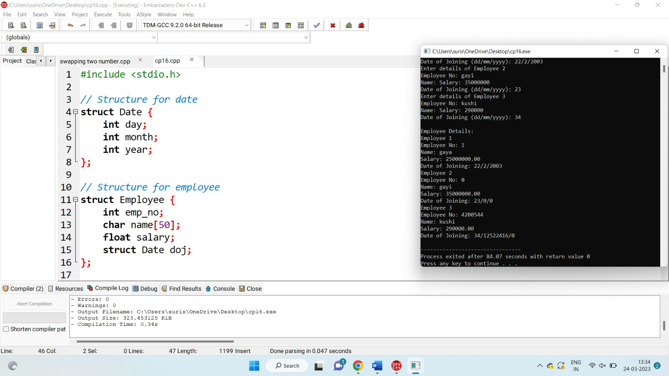

Program to find student details using nested structure

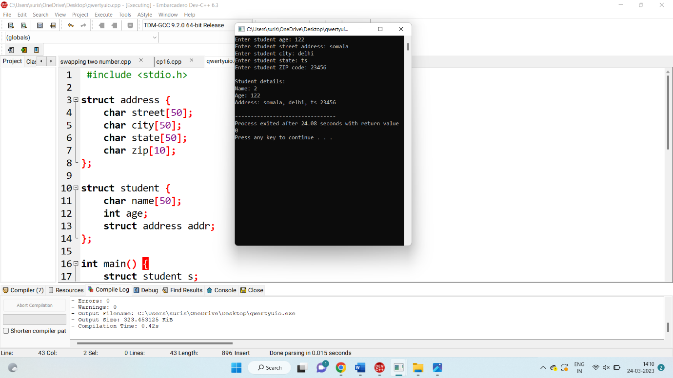

Program to store 3 book records in one structure / using array of structure

